标题：Like Stars: How Firms Learn at Scientific Conferences
作者及机构:
Stefano Baruffaldi: School of Management, Polytechnic University of Milan, 20133 Milan, Italy; and Max Planck Institute for Innovation and Competition, 80539 Munich, Germany
Felix Poege: Department of Management and Technology and ICRIOS, Bocconi University, 20100 Milan, Italy; and Max Planck Institute for Innovation and Competition, 80539 Munich, Germany
摘要: Scientific conferences are an underexplored channel by which firms can learn from science. We provide empirical evidence that firms learn from scientific conferences in which they participate but also that this is conditional on intense participation. Using data from conference papers in computer science since the 1990s, we show that corporate investments in participation are both frequent and highly skewed, with some firms contributing to a given conference scientifically, some as sponsors, and some doing both. We use direct flights as an instrumental variable for the probability that other scientists participate in the same conference as a firm, altering the knowledge set to which the firm is exposed. We find that a firm’s use of scientists’ knowledge increases when they participate in the same conferences. Greater participation efforts, where the firm seeks the spotlight by both sponsoring the conference and contributing to its scientific discourse, foretell research collaborations and a stronger learning effect. Such learning is disproportionately concentrated among the most prominent firms and scientists rather than benefitting those without alternative interaction channels. Therefore, on average, firms learn from scientists that they encounter at conferences, but the substantial heterogeneity of the effect reflects the influence of reputation mechanisms in social interactions.
AI标题: 声誉机制重构创新边界：企业高强度参与驱动知识溢出新范式
AI精炼: 【学术论文总结】 该研究聚焦企业创新管理领域，探讨公司如何通过参与科学会议获取前沿科学知识。传统研究强调企业通过雇佣、合作、地理邻近等方式获取外部知识，但对学术会议这一渠道缺乏实证验证。作者以计算机科学领域1996-2010年的6,846场会议数据为基础，创新性地将直飞航班作为工具变量，分析企业参会模式（论文发表与赞助）对知识利用效率的影响。研究发现：企业深度参与（同时提交多篇论文并赞助会议）能显著提升其引用会议论文专利的概率，且效果集中于顶尖企业与高产出科学家之间。这一结果揭示科学会议本质上是基于声誉机制的社会化空间——临时地理邻近虽降低搜索成本，但知识流动依赖于企业与科学家的主动交互及声誉匹配。与既有“知识溢出”理论不同，作者提出“明星效应”：企业需通过科学贡献（信号）与赞助（符号）建立声誉，才能激活高质量知识交换。研究为开放式创新社区参与策略提供新见解：分散式浅层投入效果有限，聚焦高强度参与才能突破社交壁垒。
关键词:
工具变量方法
准实验设计
固定效应模型
案例控制估计样本
专利引用分析
声誉机制
知识溢出效应
社会化空间
学术要点: 学术要点 1：知识接触外生性（Exogenous Knowledge Exposure） 通过直接航班作为工具变量，解决企业接触会议知识的内生性问题，控制科学家参会决策对知识流动的影响。|||
学术要点 2：赞助-科研协同效应（Sponsorship-Contribution Synergy） 企业同时进行会议赞助和科研投稿的协同参与模式，比单一参与方式产生更强的知识吸收效果。|||
学术要点 3：会议论文轨迹（Conference Paper Trails） 利用计算机科学会议论文集作为数据源，构建企业参与会议的"论文足迹"，实现大规模参会行为追踪。|||
学术要点 4：声誉主导型学习（Reputation-Driven Learning） 会议社交空间中的知识流动受声誉机制支配，顶尖企业和科学家的互动产生超额学习收益。|||
学术要点 5：学习效果异质性（Learning Effect Heterogeneity） 会议学习效应集中在已具备科学枢纽地位的企业和明星科学家之间，而非替代现有交互渠道。
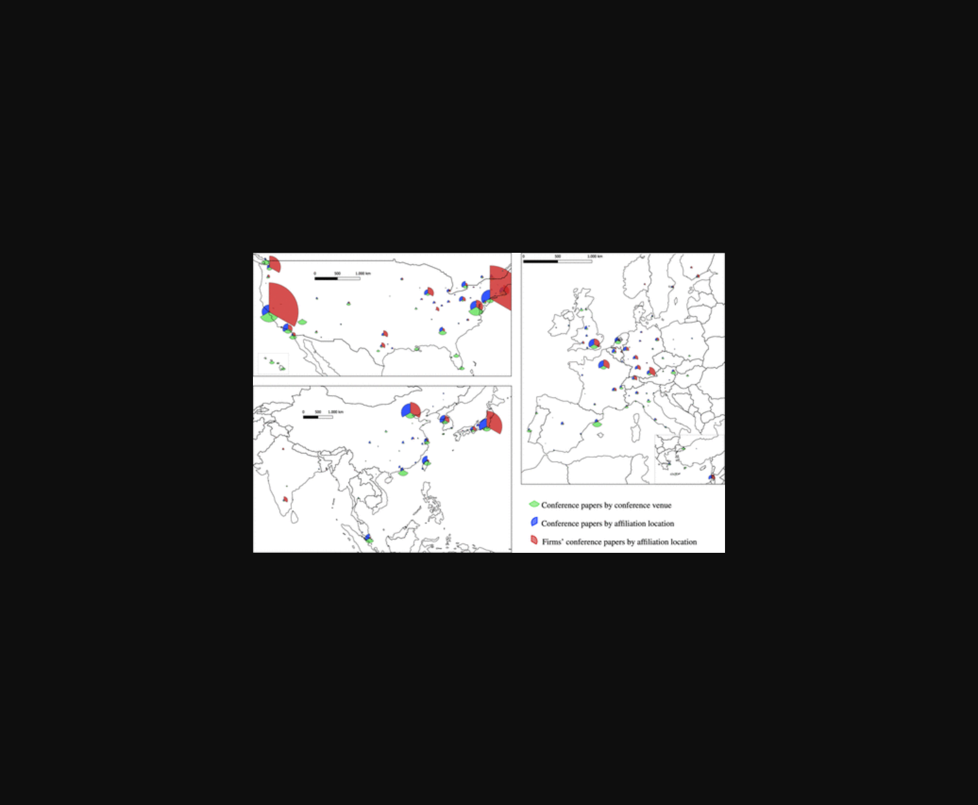
图片展示了企业参与学术会议的不同形式（赞助、发表论文）及其知识应用效果的分布情况。
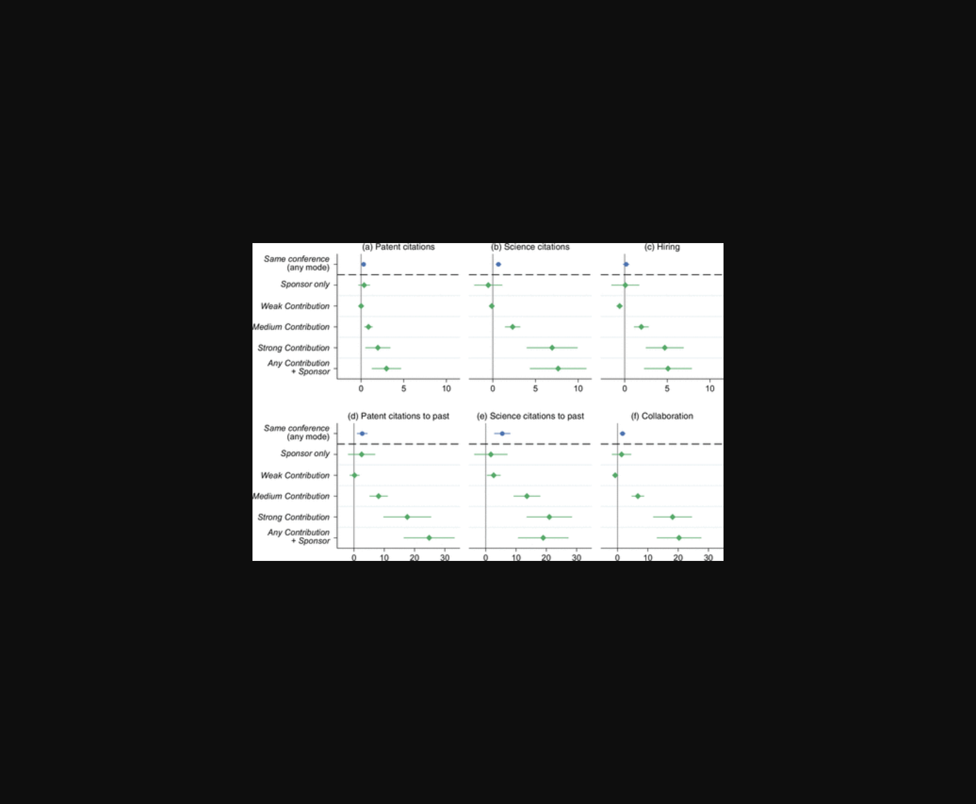
图片呈现了企业参与学术会议的赞助与论文发表分布及其知识获取关联。
原文链接: https://doi.org/10.1287/mnsc.2022.01373

